Session 6
mysql> CREATE TABLE employee (
-> emp_id INT PRIMARY KEY AUTO_INCREMENT,
-> emp_name VARCHAR(100),
-> salary INT
-> );
Query OK, 0 rows affected (0.05 sec)

mysql> DESC employee;
+----------+--------------+------+-----+---------+----------------+
| Field | Type | Null | Key | Default | Extra |
+----------+--------------+------+-----+---------+----------------+
| emp_id | int | NO | PRI | NULL | auto_increment |
| emp_name | varchar(100) | YES | | NULL | |
| salary | int | YES | | NULL | |
+----------+--------------+------+-----+---------+----------------+
3 rows in set (0.02 sec)

mysql> DELIMITER $$
mysql>
mysql> CREATE TRIGGER check_salary
-> BEFORE INSERT ON employee
-> FOR EACH ROW
-> BEGIN
-> IF NEW.salary < 0 THEN
-> SIGNAL SQLSTATE '45000'
-> SET MESSAGE_TEXT = 'Negative salary not allowed';
-> END IF;
-> END$$
Query OK, 0 rows affected (0.02 sec)

mysql>
mysql> DELIMITER ;
mysql> INSERT INTO employee (emp_name, salary)
-> VALUES ('Ravi', -5000);
ERROR 1644 (45000): Negative salary not allowed
mysql> INSERT INTO employee (emp_name, salary)
-> VALUES ('Ravi', 25000);
Query OK, 1 row affected (0.02 sec)
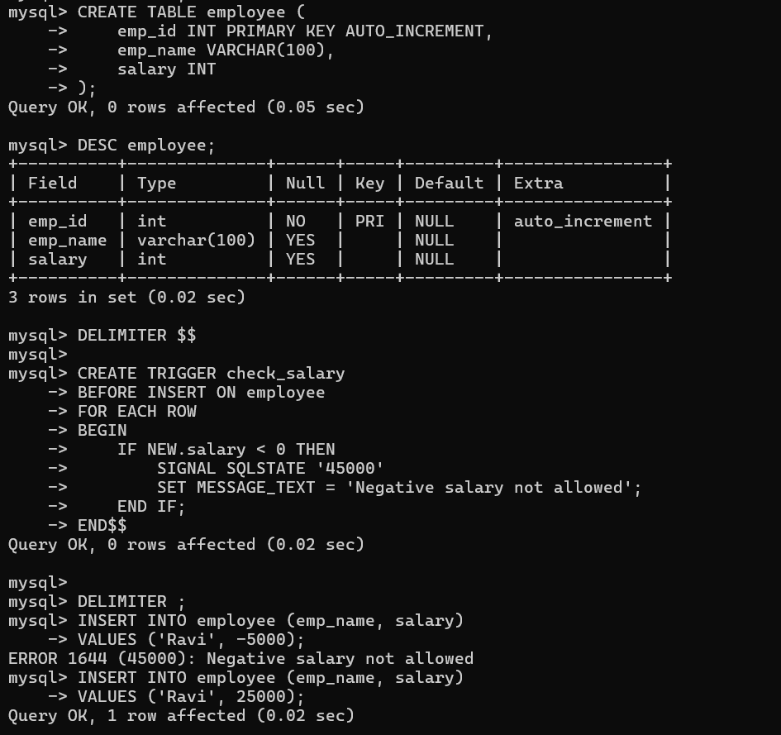
Session 7
mysql> SELECT DATEDIFF('2026-02-10','2026-01-01');
+-------------------------------------+
| DATEDIFF('2026-02-10','2026-01-01') |
+-------------------------------------+
| 40 |
+-------------------------------------+
1 row in set (0.01 sec)

mysql> SELECT DATE_ADD(CURDATE(), INTERVAL 30 DAY);
+--------------------------------------+
| DATE_ADD(CURDATE(), INTERVAL 30 DAY) |
+--------------------------------------+
| 2026-03-05 |
+--------------------------------------+
1 row in set (0.01 sec)

mysql> SELECT DATE_SUB(CURDATE(), INTERVAL 7 DAY);
+-------------------------------------+
| DATE_SUB(CURDATE(), INTERVAL 7 DAY) |
+-------------------------------------+
| 2026-01-27 |
+-------------------------------------+
1 row in set (0.00 sec)

mysql> SELECT MONTHNAME(STR_TO_DATE('07-01-2026','%d-%m-%Y'));
+-------------------------------------------------+
| MONTHNAME(STR_TO_DATE('07-01-2026','%d-%m-%Y')) |
+-------------------------------------------------+
| January |
+-------------------------------------------------+
1 row in set (0.01 sec)
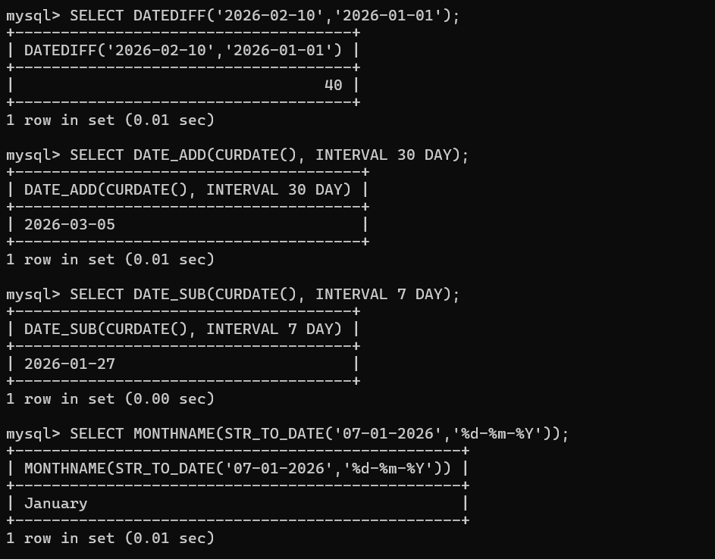
Session 8
mysql> CREATE TABLE organizer (
-> org_id INT PRIMARY KEY AUTO_INCREMENT,
-> name VARCHAR(100),
-> contact VARCHAR(20),
-> email VARCHAR(100),
-> status VARCHAR(20),
-> created_at DATETIME
-> );
Query OK, 0 rows affected (0.03 sec)

mysql> DESC organizer;
+------------+--------------+------+-----+---------+----------------+
| Field | Type | Null | Key | Default | Extra |
+------------+--------------+------+-----+---------+----------------+
| org_id | int | NO | PRI | NULL | auto_increment |
| name | varchar(100) | YES | | NULL | |
| contact | varchar(20) | YES | | NULL | |
| email | varchar(100) | YES | | NULL | |
| status | varchar(20) | YES | | NULL | |
| created_at | datetime | YES | | NULL | |
+------------+--------------+------+-----+---------+----------------+
6 rows in set (0.00 sec)

mysql> INSERT INTO organizer (name, contact, email, status, created_at) VALUES
-> ('Anil', '9845012345', 'anil@mail.com', 'active', NOW()),
-> ('Bhavya', '9845023456', 'bhavya@mail.com', 'inactive', NOW()),
-> ('Charan', '9845034567', 'charan@mail.com', 'active', NOW()),
-> ('Divya', '9845045678', 'divya@mail.com', 'active', NOW()),
-> ('Esha', '9845056789', 'esha@mail.com', 'inactive', NOW());
Query OK, 5 rows affected (0.01 sec)
Records: 5 Duplicates: 0 Warnings: 0

mysql> CREATE INDEX idx_contact ON organizer(contact);
Query OK, 0 rows affected (0.04 sec)
Records: 0 Duplicates: 0 Warnings: 0

mysql> CREATE UNIQUE INDEX idx_unique_email ON organizer(email);
Query OK, 0 rows affected (0.05 sec)
Records: 0 Duplicates: 0 Warnings: 0

mysql> DROP INDEX idx_contact ON organizer;
Query OK, 0 rows affected (0.02 sec)
Records: 0 Duplicates: 0 Warnings: 0

mysql> CREATE INDEX idx_email_search ON organizer(email);
Query OK, 0 rows affected (0.04 sec)
Records: 0 Duplicates: 0 Warnings: 0

mysql> SELECT * FROM organizer WHERE email = 'anil@mail.com';
+--------+------+------------+---------------+--------+---------------------+
| org_id | name | contact | email | status | created_at |
+--------+------+------------+---------------+--------+---------------------+
| 1 | Anil | 9845012345 | anil@mail.com | active | 2026-02-03 10:00:03 |
+--------+------+------------+---------------+--------+---------------------+
1 row in set (0.00 sec)

mysql> CREATE INDEX idx_status_created
-> ON organizer(status, created_at);
Query OK, 0 rows affected (0.05 sec)
Records: 0 Duplicates: 0 Warnings: 0
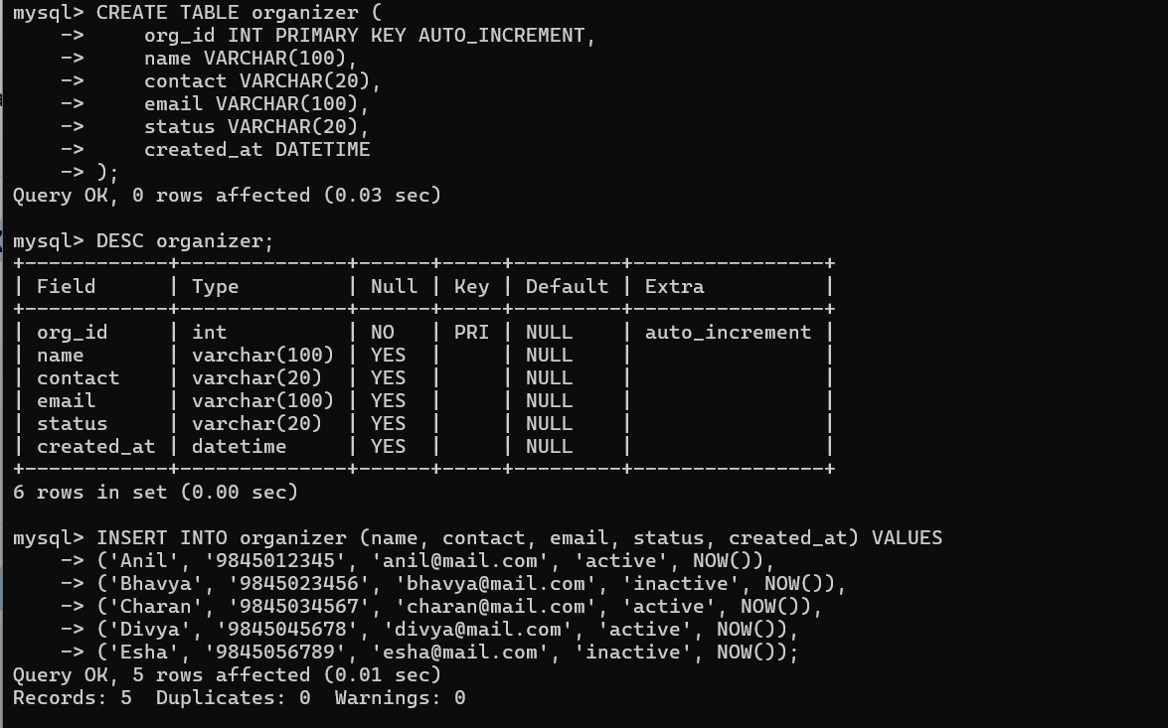

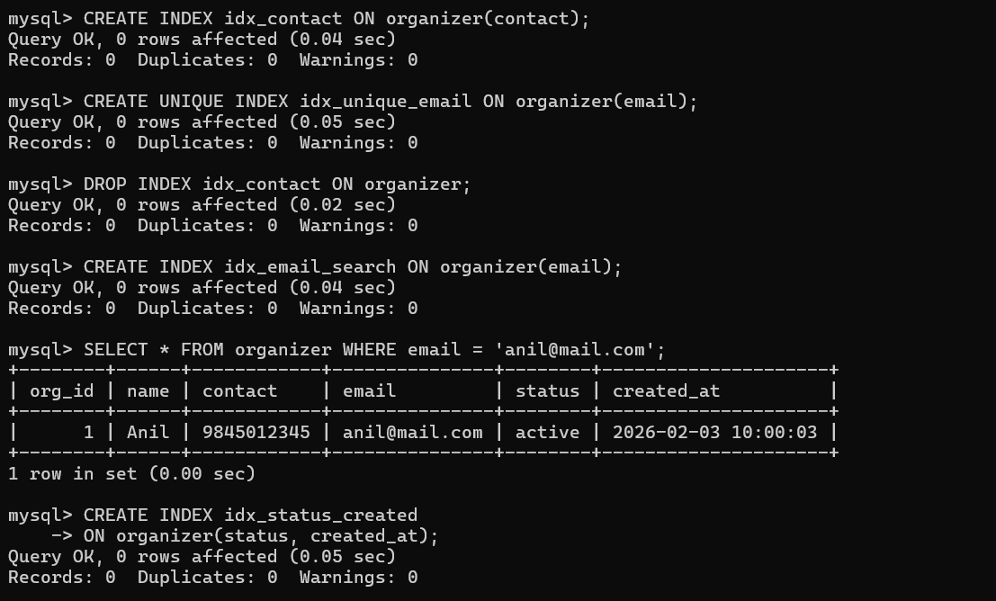
Session 9
mysql> SELECT
-> UPPER(Name) AS Name_Upper,
-> LOWER(Name) AS Name_Lower
-> FROM Student;
+------------+------------+
| Name_Upper | Name_Lower |
+------------+------------+
| ARJUN | arjun |
| SNEHA | sneha |
| RAHUL | rahul |
| PRIYA | priya |
| AMIT | amit |
| KIRAN | kiran |
+------------+------------+
6 rows in set (0.01 sec)

mysql> SELECT
-> CONCAT(
-> UPPER(SUBSTRING(Name,1,1)),
-> LOWER(SUBSTRING(Name,2))
-> ) AS Normalized_Name
-> FROM Student;
+-----------------+
| Normalized_Name |
+-----------------+
| Arjun |
| Sneha |
| Rahul |
| Priya |
| Amit |
| Kiran |
+-----------------+
6 rows in set (0.00 sec)

mysql> SELECT
-> CONCAT(SUBSTRING_INDEX(Email,'@',1),'123') AS Default_Password
-> FROM Student;
+------------------+
| Default_Password |
+------------------+
| arjun123 |
| sneha123 |
| rahul123 |
| priya123 |
| amit123 |
| kiran123 |
+------------------+
6 rows in set (0.00 sec)

mysql> SELECT
-> Phone,
-> REPLACE(REPLACE(Phone,'-',''),' ','') AS Clean_Phone
-> FROM Student;
+---------------+---------------+
| Phone | Clean_Phone |
+---------------+---------------+
| +919845011223 | +919845011223 |
| 9845022334 | 9845022334 |
| +919845033445 | +919845033445 |
| 9845044556 | 9845044556 |
| 9845055667 | 9845055667 |
| 9999999999 | 9999999999 |
+---------------+---------------+
6 rows in set (0.01 sec)
mysql> SELECT
-> Name,
-> COALESCE(Phone, Email) AS Preferred_Contact
-> FROM Student;
+-------+-------------------+
| Name | Preferred_Contact |
+-------+-------------------+
| Arjun | +919845011223 |
| Sneha | 9845022334 |
| Rahul | +919845033445 |
| Priya | 9845044556 |
| Amit | 9845055667 |
| Kiran | 9999999999 |
+-------+-------------------+
6 rows in set (0.00 sec)
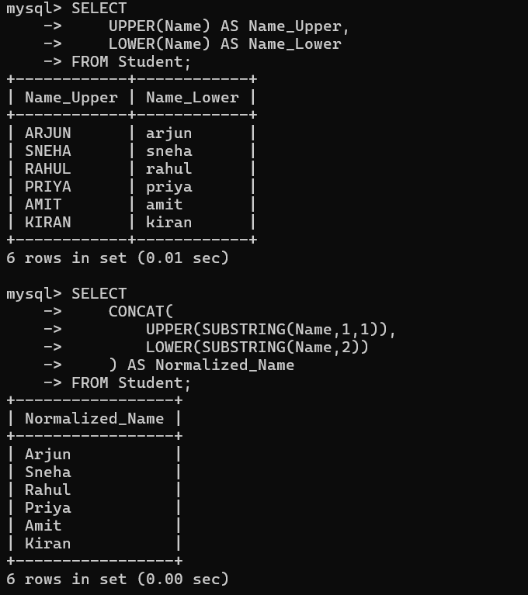
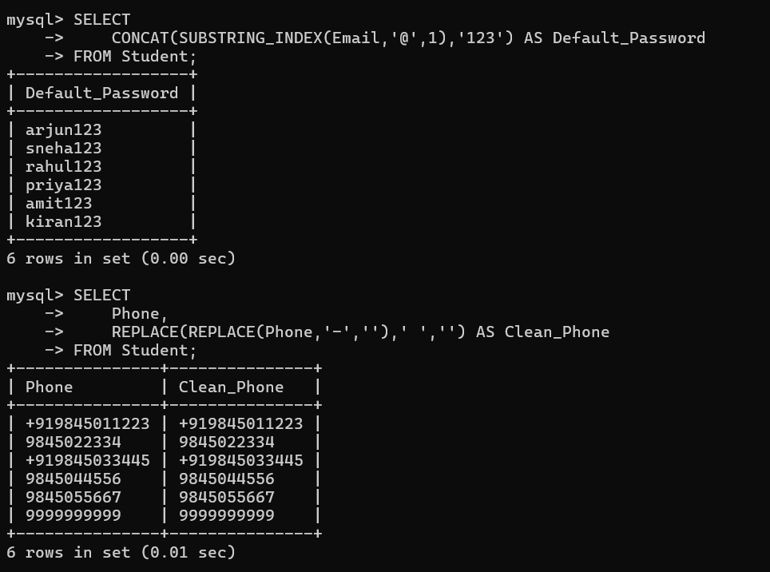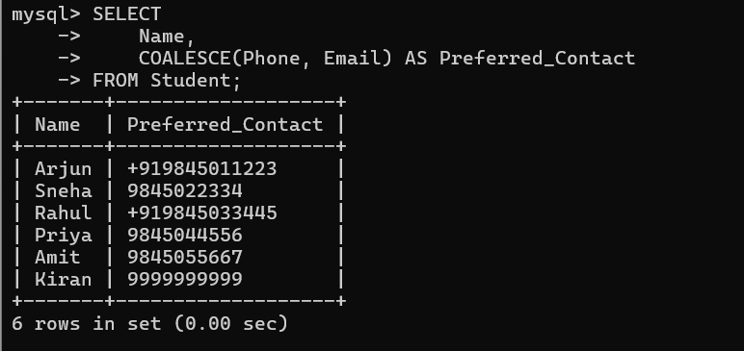
Session 10
mysql> CREATE FUNCTION add_numbers(a INT, b INT)
-> RETURNS INT
-> DETERMINISTIC
-> BEGIN
-> RETURN a + b;
-> END$$
Query OK, 0 rows affected (0.01 sec)

mysql>
mysql> DELIMITER ;
mysql>
mysql> SELECT add_numbers(5, 10);
+--------------------+
| add_numbers(5, 10) |
+--------------------+
| 15 |
+--------------------+
1 row in set (0.01 sec)

mysql> DELIMITER $$
mysql>
mysql> CREATE FUNCTION total_students()
-> RETURNS INT
-> DETERMINISTIC
-> BEGIN
-> DECLARE total INT;
-> SELECT COUNT(*) INTO total FROM Student;
-> RETURN total;
-> END$$
Query OK, 0 rows affected (0.01 sec)

mysql>
mysql> DELIMITER ;
mysql> SELECT total_students();
+------------------+
| total_students() |
+------------------+
| 6 |
+------------------+
1 row in set (0.01 sec)



